EE642 PROJECT

USER MANUAL ver 1.2

by Salim SIRTKAYA

SCOPE
This document is written to inform the user about effective and easy use of the Graphical User Interface (GUI) of the “ EE642 -Computer Graphics Course Project” implementation written by Salim SIRTKAYA. You’ll also find a brief explanation about the details of the implementation. This document is the second version of the current subject.

PROJECT DETAILS
The project is implemented in Visual C++ version 6.0. In order to scan or analyze the source code efficiently in a project environment you should have Visual C++ 6.0 installed in your computer. You can alternatively analyze individual C++ files. However due the nature of Visual C++ development environment and object-oriented programming constraints there exist a huge number of C++ or header files and it may be difficult to browse the right content among them. Therefore analyzing the source with Visual C++ is strongly recommended. You should open the *.dsw file in the Visual C++ 6.0 IDE for opening the project.

TIPS FOR THE USER
! Start the program by double clicking on EE642Project_Salim.exe. You will see a graphical user interface

! The GUI screen is divided into four main parts.
- Menu items at the upper left part
- Static textual information area at the lower left part
- Display area at the upper right part
- Dynamic textual information area at the lower right part

! The GUI has a menu architecture and you can browse between the menus by clicking the buttons on the corresponding part. The menu architecture is given in Figure 1.

! There exist a static button in all menus which clears the display area (“Clear Screen” button).
! In the “LOAD” menu, you can select between predefined object such as line, triangle, square, cube with triangular facet etc.. After selecting the object, you can go to the “EDIT” menu and apply transformations by clicking the corresponding button.

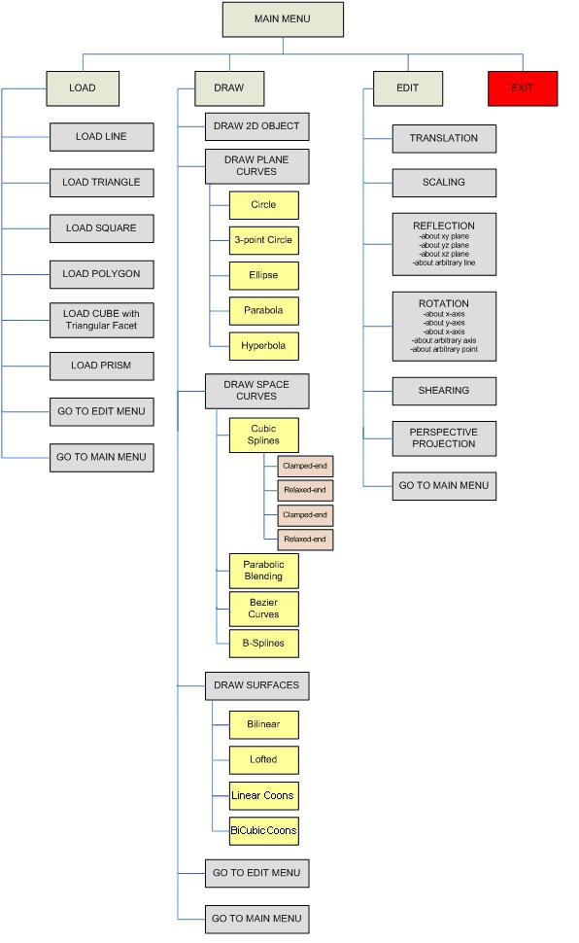
Figure 1 Menu architecture

! In “DRAW” menu, you can draw an arbitrary 2D object or draw plane curves such as circle, ellipse etc., draw space curves such as cubic splines, bezier curves, b-splines, draw surface patches such as Bilinear, Linear Coons, Bicubic Coons etc.

! In “EDIT” you can select the type of transformation you like to conduct. The choices are given in Figure 1. Some choices need user intervention. For example if you select “Rotation About an Arbitrary Point” transformation, you’ll need to select this arbitrary point on the display area by left clicking the mouse to the desired location. If a choice needs user intervention, there will be a small explanation about the required action in the “dynamic textual information” part.

! There exists radio buttons in some transformation menu where you can sub-select some necessary parameters.

! After you conduct any transformation on an object, you will see two objects in the screen. The one with dashed green lines is the original object and the one with solid orange lines is the transformed object.

! The transformations are conducted on the last transformed object, not the original object.

! In the “dynamic textual information” (INFO at lower left), you’ll see brief explanations about the current menu, and instructions about possible actions that should be taken by the user, for proper operation.

! In the “static textual information” part (at lower right), you’ll see the height, width and grid informations about the display area. The current location of the mouse on the display area is also shown in thism part.

! The width of the display screen is 600 pixels, the height is also 600 pixels. The grid is a 50x50 pixels square.

! The origin is at the center of the display area.

! X and Y axes are mentioned in the display. Z axis is normal to the screen and directing to you.

! You can conduct a transformation, after entering the necessary inputs, by clicking the apply button or pressing “enter” on your keyboard.

! You can close the program by pressing “esc” on your keyboard or by pressing the close icon on the upper right corner of the program area or pressing the “EXIT” button on the main menu.

